Setting up the Voyager ArcMAP Add-in with ArcGIS Desktop

1. To set up the Voyager ArcMAP Add-in, go to the **${install.dir}/app/esri/addin** folder.

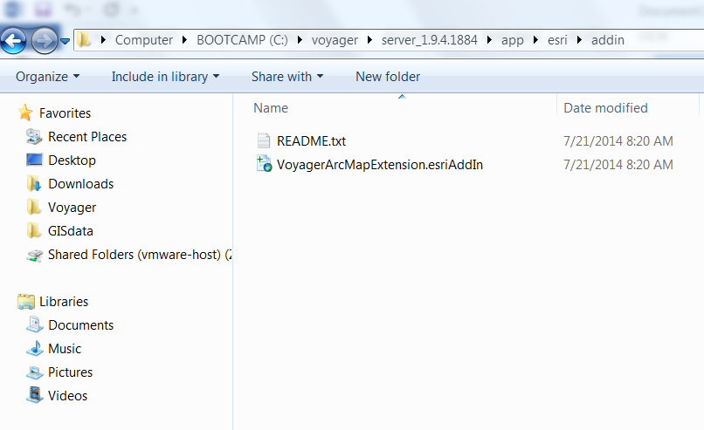

1. Copy the *VoyagerArcMapExtensionesriAddIn* file to the computer where ArcGIS Desktop is installed
2. Double-click *VoyagerArcMapExtensionesriAddIn* file and click **Install Add-in**

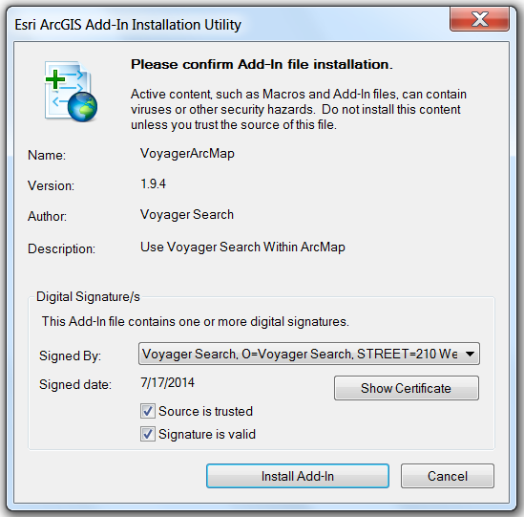

1. Open **ArcMap** and select **Customize**
2. In the **Customize** window, select the **Commands** tab and enter Voyager in the **Show commands containing:** search box
3. Click and drag the Voyager Search tool from the **Commands** tab to any toolbar in **ArcMap**
4. Close the **Customize** window
5. Click **Voyager Search** to open the Voyager dockable window. The **Setup** tab is selected by default and queries <http://localhost:8888/voyager/?VOYAGERINFO> to populate the Voyager URL

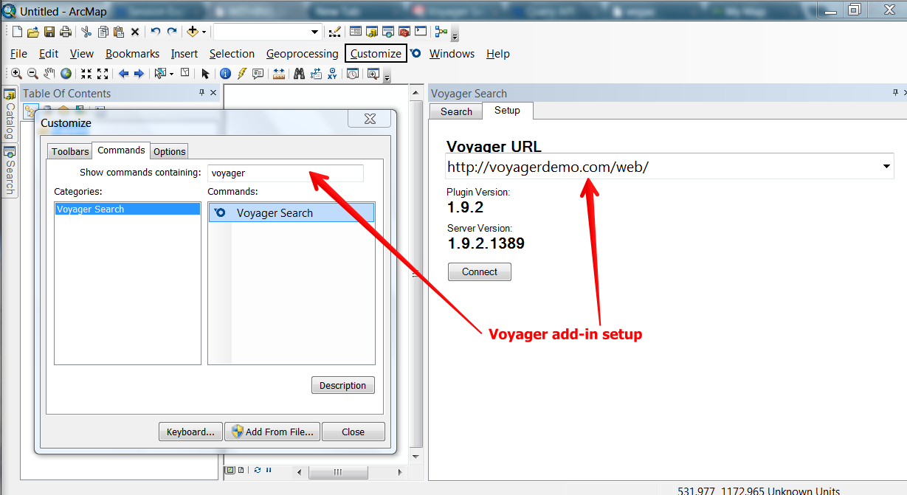

1. Click **Connect** to open the Summary view (or a login dialog if security is enabled)
2. You now can search using the text search, spatial search and filter on data types

